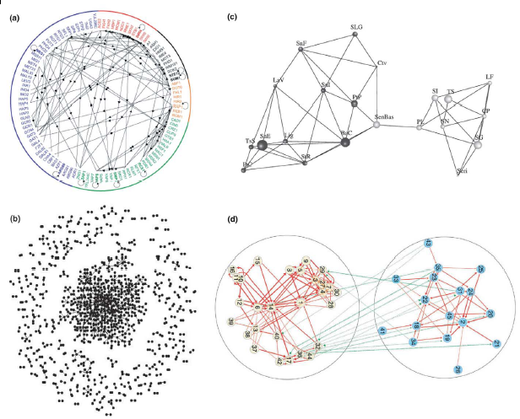
Examples of Biological Networks?

c. What are appropriate network descriptions?
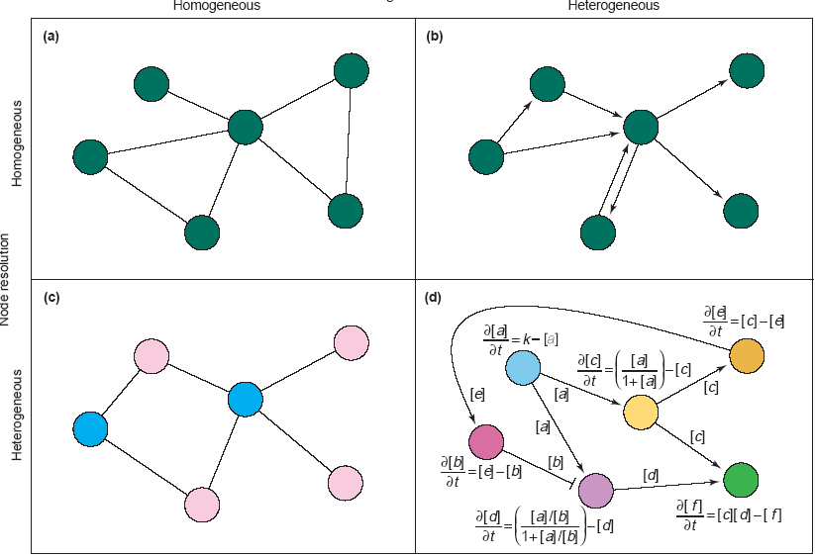

dynamic description
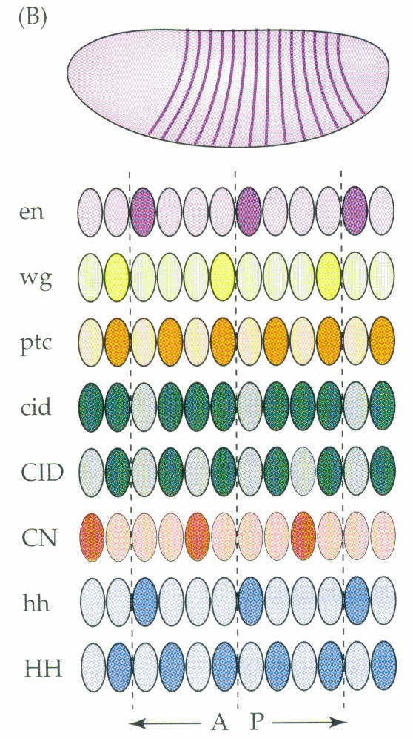
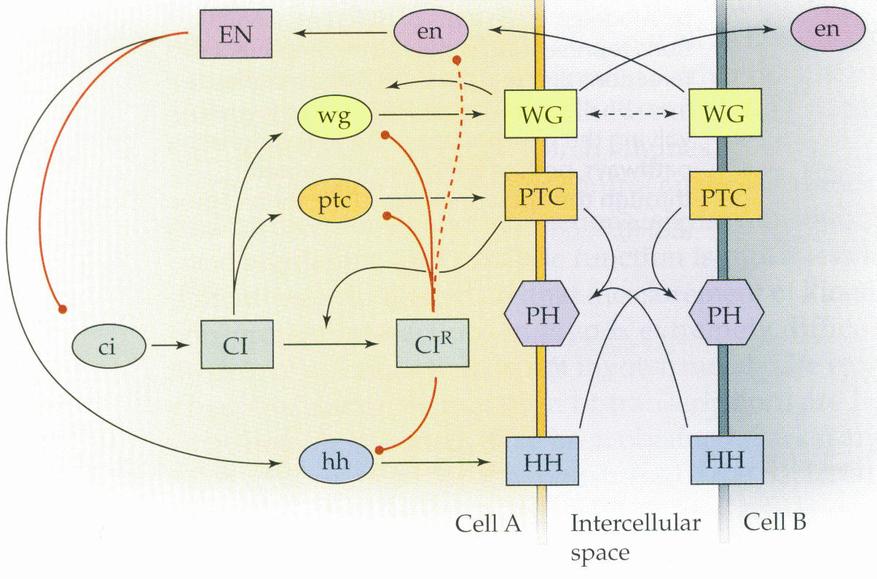
Garry O’Dell, Nature 2001:
19 equations, 54 parameters,

1/2000 random solutions → correct spatial structure.

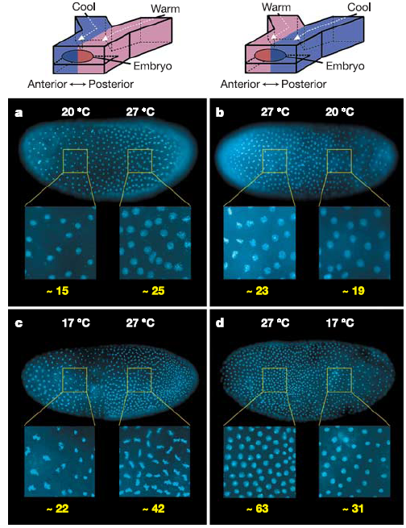
Most parameters can vary 10,000 fold causing no changes, Mutation-selection balance?
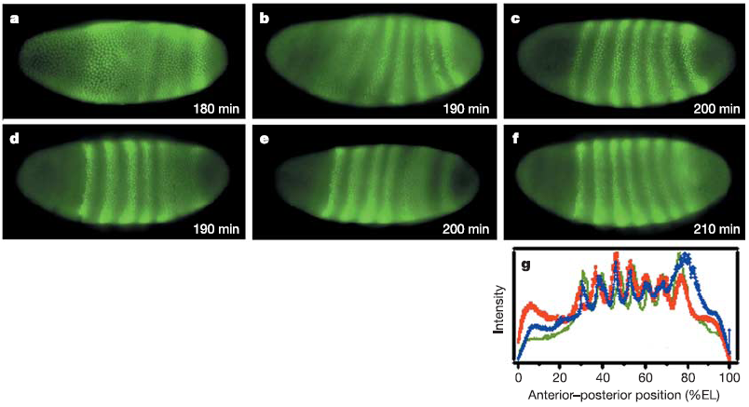

How to integrate with evolutionary genetics?
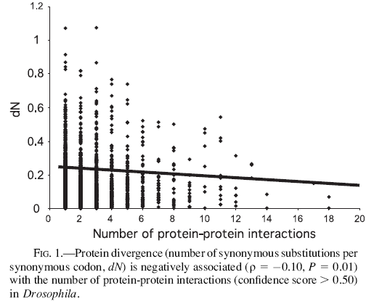
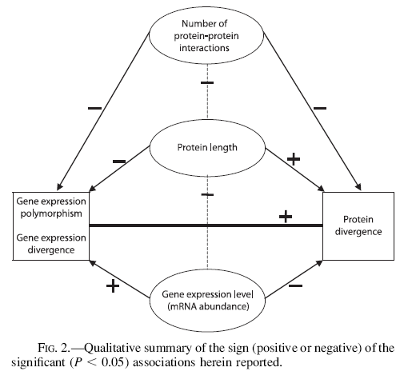
1. Data mining;

2. Analysis of natural variation.
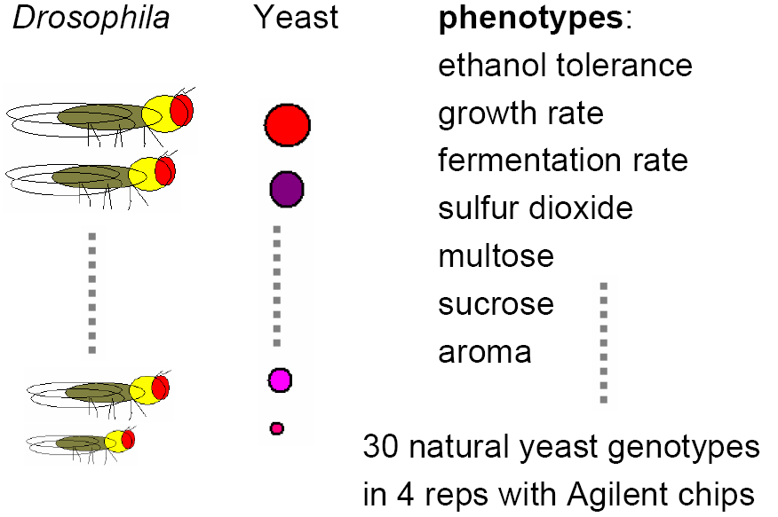
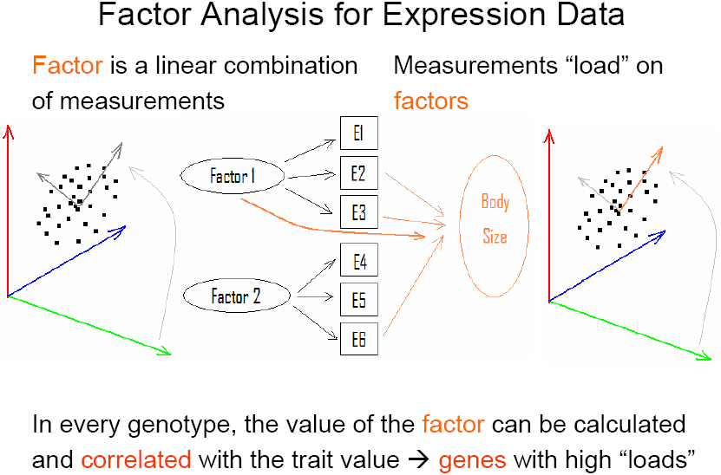
500 genotypes → 30 Agilent chips → 4 per genotype
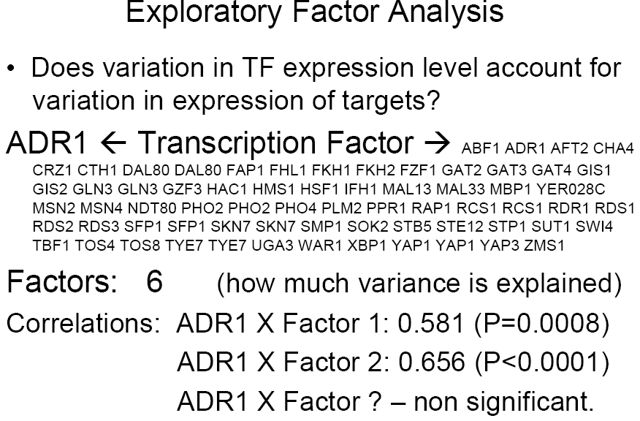

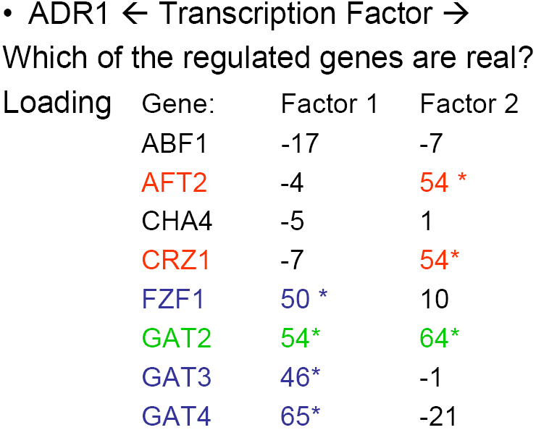

May we model in the same framework not a single connection but all of the network?
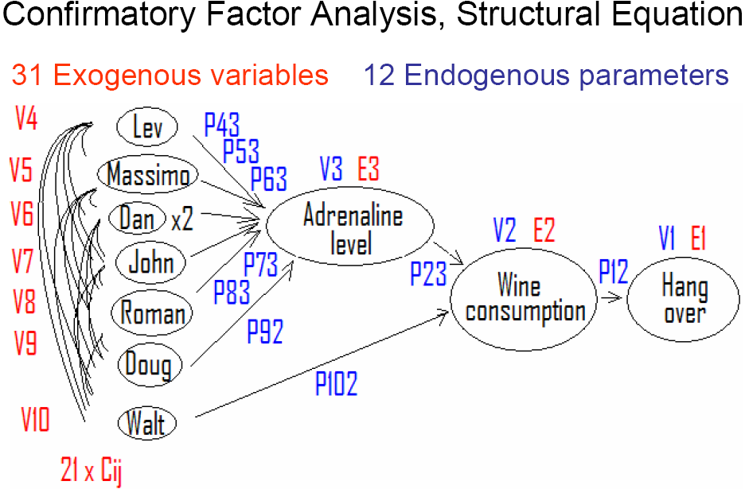

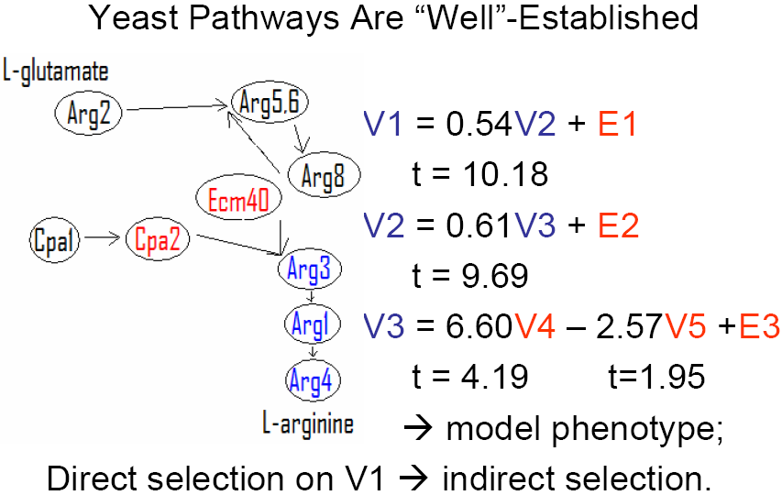

How do networks evolve between species?
- take a network from model;
- measure variance-covariance in non-model;
- check whether the original network is still the best-supported
one.

